

**GenC FTE Skilling**

**Program Guidelines 2025**

**India**

**Table of Contents**

1 Introduction 4

2 Scope of the document 4

3 Purpose 4

4 GenC Program Overview 4

5 Acronyms and Definitions 6

Acronyms 6

6 Guidelines 6

7 Skilling completion criteria for GenC FTE 7

7.1 Technical Competencies 7

7.1.1 Stage 1 7

7.1.2 Stage 2 and beyond (Advanced skilling stages) 7

7.1.2.1 RAG Definition 8

7.1.2.2 Skilling completion criteria from Stage 2 and attempt eligibility 9

7.1.2.3 Gating criteria Beyond Stage 2 9

Note 9

7.1.2.4 Profiling Assessment 10

8 Behavioral Competencies 10

8.1 Expectation post FTE onboarding 10

9 Attendance health Status 11

10 Code of Ethics - Guiding Principles 11

10.1 Attendance Health score Guidelines 13

10.1.1 AHS RAG 13

10.1.2 AHS Consequence 13

10.1.3 FTE leave policy 13

10.1.4 Break Scenario 14

10.2 Integrity in Assessments 14

10.2.1 What constitutes Malpractice 14

10.3 Deployment guidelines 15

10.4 Communication protocols 15

10.4.1 GenC Program communication Escalation Matrix 15

10.4.2 Mail format 16

11 GenC Grievance cell 17

11.1 How does the grievance cell work? 17

11.2 Grievance Categories 18

12 Feedback communication to the GenC 18

13 Outliers/Exceptions 18

14 Appendix 19

14.1 Definitions 19

14.2 Gen Catalyst Professional Development program 20

# Introduction

The Generation Cognizant Program (GenC Program) caters to the Entry Level Training within Cognizant in India. stretches across the entire timeline of a campus hire's learning journey from the time he/she accepts the offer letter from the company - to the first year of his/her tenure in the organization. There is a robust learning strategy put in place across each of the stages:

* Pre-Onboarding (Early Engagement, Campus engagement, Internship, Certified skill development)
* GenC FTE training
* Year One Enablement
* Continuous Role Development

# Scope of the document

This document covers the **guidelines for GenC Full time Employee (FTE) trainees** in Cognizant at India for On –Campus and Off-campus selects going through Cognizant GenC skilling program enablement via Classroom/Virtual / Hybrid *(Classroom & Virtual)* mode in the year 2025. These guidelines are applicable to all types of skilling programs (Skilling/Re-skilling pre & post onboarding to the skilling program)

The duration and exit criteria of the **GenC FTE skilling** program will be determined by the curriculum track to which the GenC is mapped as per the business demand. *(Refer Section7.1.2 for details)*

# Purpose

The purpose of this document is to define the approach towards Cognizant **GenC FTE** 2025 skilling completion from the HR GenC Program standpoint.

The GenC curriculum is designed to with the focus to enable GenC FTEtrainees to incorporate the skills acquired, by developing real time projects/use cases as well as considerably improve their professional skills as they progress through the program.

# GenC Program Overview

The GenC (Generation Cognizant) Program assures skill capability in our fresh hires (GenCs) towards business readiness at Cognizant. This program spans the entire duration of GenCs learning journey from the time GenCs accept Cognizant offer, through the first-year completion as an FTE in the organization. There is a robust learning strategy put in place across four phases.

In the Cognizant GenC skilling program, the FTE trainees are provided with a learning path, and their performance is assessed as per the milestones in the curriculum including meeting the gating criteria for the curriculum assigned, completion of learning/assessment's/Hands-on assignments as per the given schedule including adherence to the skilling program guidelines.

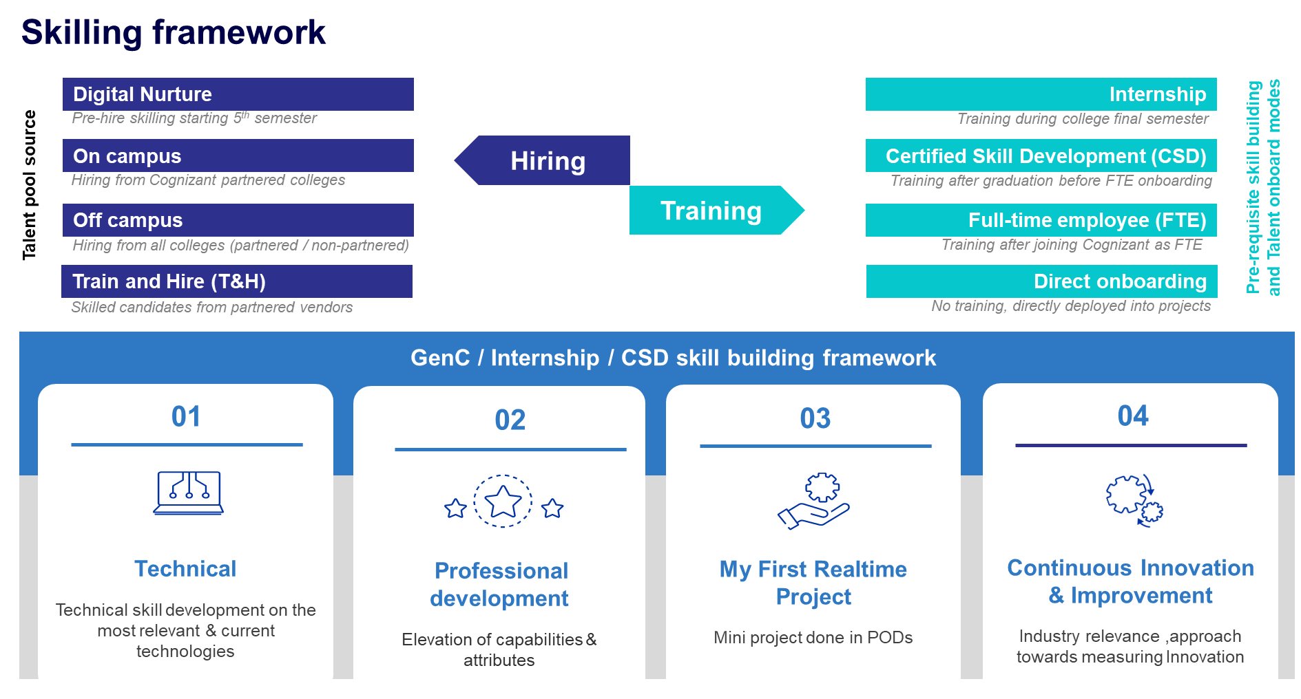

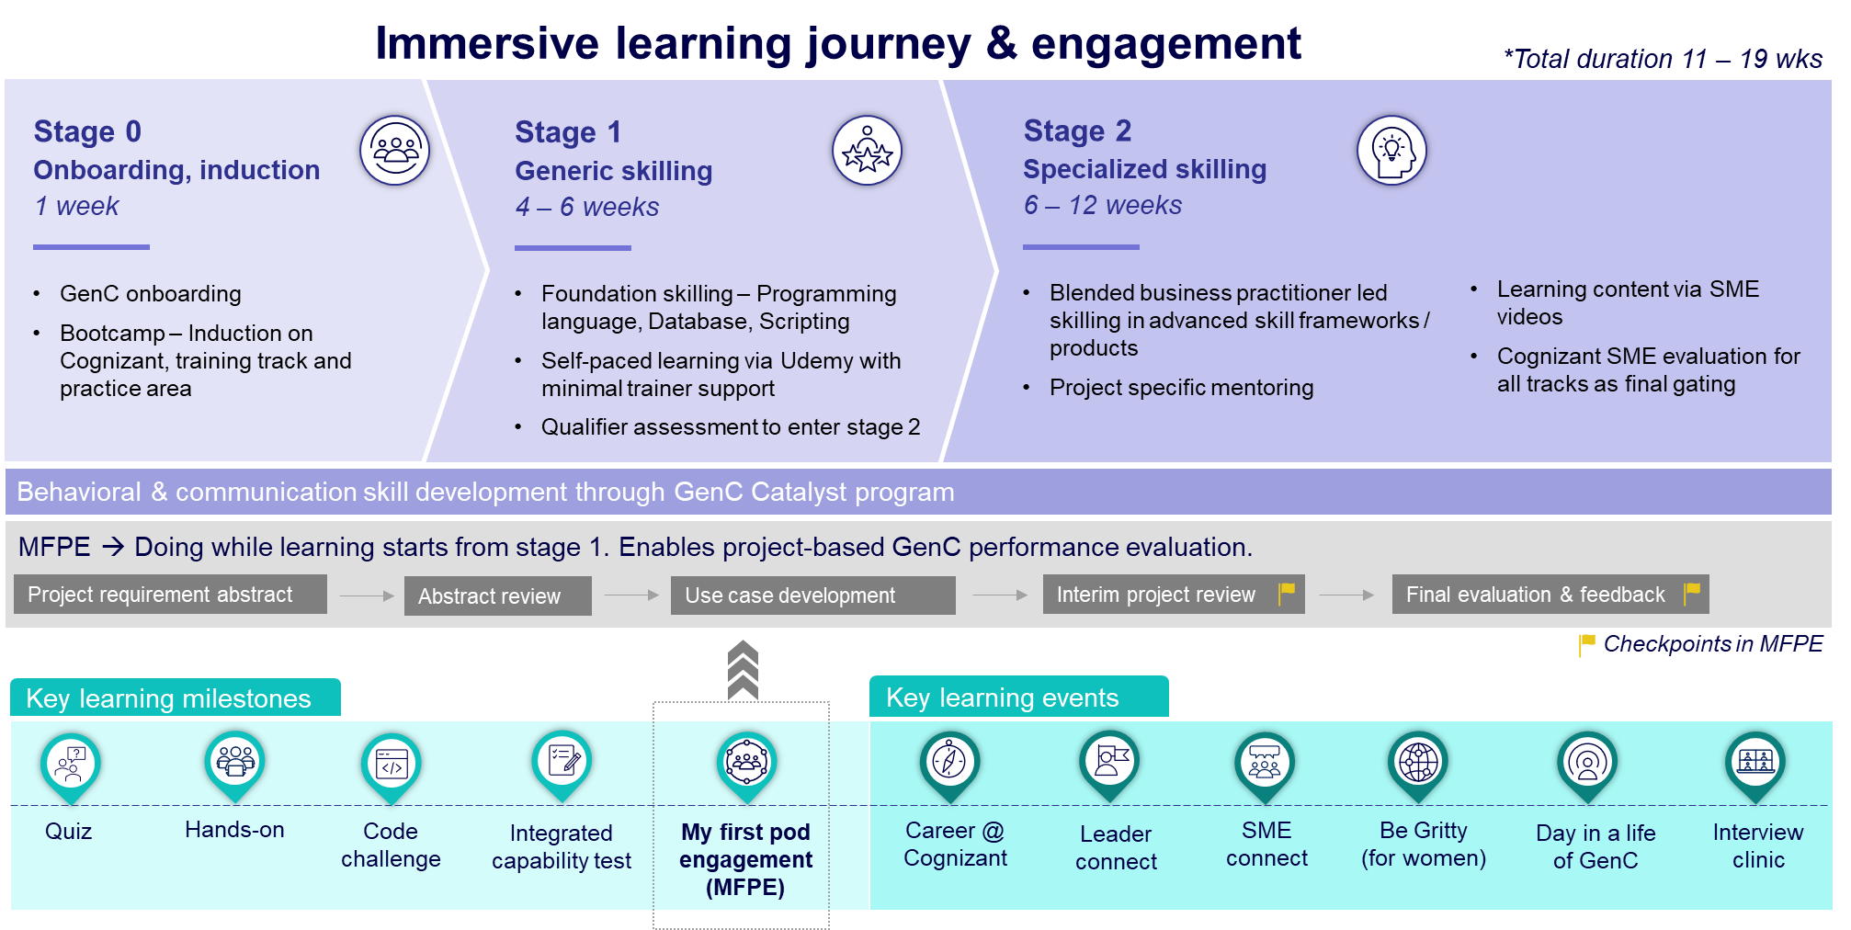

# Acronyms and Definitions

Few of the acronyms and / or its definitions provided here may not have been used in this document but has been provided for easy reference to their definitions.

## Acronyms

|  |  |
| --- | --- |
| Acronym | Description |
| GenC | Generation Cognizant |
| SL | Service Line |
| BU | Business Unit |
| FTE | Full Time Employee |
| PHS | Performance Health Status |
| AHS | Attendance Health Status |
| RAG | Red, Amber, Green |
| LOI | Letter of Intent |
| CEFR | Common European Framework |
|  |  |

# Guidelines

The overall performance of the GenC will be assessed across the evaluation/assessment modules and the eligibility criteria for successful completion of skilling program will include the GenC’s technical competency, behavioral competencies and adherence to policy aligned to GenC FTE skilling program guidelines.

# Skilling completion criteria for GenC FTE

# Technical Competencies

Every GenC is mapped to a technical track based on the business demand and provided systematic training to develop their technical skills. Each technical track has a defined curriculum which is oriented to the GenCs at the beginning of the technical skilling phase. Towards successful completion of the skilling program, the GenC's are expected to demonstrate their comprehension and ability to implement the technical concepts as per the defined curriculum.

The details on the skilling completion criteria relating to technical skilling across fundamental & advanced levels are as explained below:

The **technical performance skilling and evaluation** will happen at two levels:

1. Stage 1 [Fundamentals]
2. Stage 2 and beyond as applicable [Advanced skilling stages]

### Stage 1

Stage 1 in the training curriculum of each track will be the qualifier stage to progress to the advanced skilling stages.

* The GenC FTEs are expected to obtain >=70% score in the stage 1 assessment.
* 100% completion of hands-on exercises assigned in stage 1 curriculum is mandatory to be eligible for stage 1 assessment.
  + - * Catch-up instance will be provided to complete hands-on and attempt stage1 assessment.

|  |  |
| --- | --- |
| **Stage 1 passing criteria** | **GenC FTE** |
| **>= 70% in stage 1 assessment** | Proceed with stage 2 learning |
| **< 70% in stage 1 assessment** | Proceed with stage 2 in parallel to stage 1 reattempt.  Pass stage1 assessment 2 before completion of Stage 2 final evaluation. |

Stage 1 completion is mandatory for the successful fulfillment of the GenC FTE skilling program. Depending on the specific training track, trainees who fail to pass stage 1 could be prevented from taking the final evaluation, consequently not meeting the criteria for skilling program completion.

### Stage 2 and beyond (Advanced skilling stages)

From Stage 2, the trainee’s technical proficiency and their ability to implement the skills will be evaluated to determine their Performance Health Status (PHS) based on a one-to-one evaluation by a Subject Matter Expert (SME). The SME evaluation will be a single event covering both technical and project implementation aspects conducted at two checkpoints during the skilling phase: (i) Interim Evaluation (ii) Final evaluation.

1. The interim evaluation is conducted at a logical midpoint during the advanced skilling stages. A trainee's learning progress is assessed during the interim evaluation, and an interim PHS is provided along with feedback to assist them in achieving their final evaluation goals.
2. The final evaluation is conducted at the end of the technical skilling phase and the trainee is assessed on the entire set of skills he has learned in the curriculum. Final evaluation results are presented in Red/Amber/Green as Performance Health Status (PHS).

At the end of technical skilling phase, the GenC FTE trainees are expected to have a performance health status of 'Green' to be eligible for successful completion of the GenC skilling program.

If the PHS status is Red or Amber in the final evaluation, the trainee will be ineligible for project deployment and continued employment with the organization. HR will initiate Trainee Consequence Management procedures.

#### RAG Definition

|  |  |
| --- | --- |
| **Red** | Trainee is not able to answer the basic questions asked on the particular skill. Trainee has implemented a few project requirements and unable to answer questions on the project clearly.  Trainee is not able to respond in complete sentences to the questions asked, struggles to find the words and unable to comprehend questions, poor attitude towards learning, |
| **Amber** | Trainee is able to answer basic questions and some of scenario-based questions without detailed explanation. Trainee has implemented few of project requirements and able to present, explain and answer basic questions on project. Trainee is able to respond in complete sentences to questions, using too many fillers, having good attitude and finds difficult to comprehend the questions. |
| **Green** | Trainee has good understanding on skill and able to answer most of the basic and scenario-based questions. Trainee has implemented most of the project requirements, able to present the requirement well and answer the questions related to project. Trainee speaks clearly with right attitude, maintains eye contacts, and speaks confidently and able to articulate his/her thoughts. |

#### Skilling completion criteria from Stage 2 and attempt eligibility



Evaluation components may be included, modified, or excluded based on SL discretion and GenC program head approval. *Refer section 7.1.3*

#### Gating criteria Beyond Stage 2

|  |  |  |  |
| --- | --- | --- | --- |
| GenC Skilling | Overall Evaluation Components | Pass Criteria | Evaluation Done by |
| **Performance Health Status - PHS**  *(Only from Stage 2)* | Interim Evaluation  (Project + Technical)  *(Refer curriculum details for SL specific evaluation components)* | Passing criteria & the eligible number of attempts are as given in 7.1.2.2 | BU SME |
| Final Evaluation  (Project + Technical)  *(Refer curriculum details for SL specific evaluation components)* |

### Note

* Evaluation would be scheduled through GenC Learn platform and evaluator will update RAG status and feedback in the platform.
* Evaluations to happen at an individual level in person and on video and mandatorily recorded. (*Even if the GenC FTE & the evaluator are in the same location)*
* 100% Completion of Hands on in Stage 2 is mandatory for interim / final evaluation eligibility.
* Eligible for “Successful completion” indicates that the GenC FTE trainee has met the performance threshold set at the checkpoint.
* **Re-attempt on** Final evaluation would be provided will be applicable for as per above rubrics.
  + *Trainee is not eligible for final evaluation re-attempt, if both Interim/Final evaluation (attempt 1) status is Red.*
* **Remedial Phase:** Additional **1 week** post the Tentative/Planned Graduation date is the permissible time, provided to any GenC to successfully complete all the pending components (backlog including project / technical evaluations). Consequence management activities start based on the Performance status at the end of this remedial phase.
  + **If GenC FTE trainee underperforms at the end of remedial phase**, exit process will be followed.
  + There could be exception to deployment clause based on the demand & training outcomes, at the discretion of the ISL and GenC Program head approval.

#### Profiling Assessment

Profiling assessments are conducted during bootcamp or within the first week of training, ensuring early validation of foundational competencies without disrupting the training flow. Training will commence on the 6th day from the date of joining, irrespective of assessment completion. These assessments are particularly relevant for off-campus hires at PAT Level who are mapped to Direct Stage 2 or Delta + Stage 2. However, based on assessment outcomes, additional learning support may be introduced if necessary.

The actual profiling assessment will be conducted on Day 1 of technical training via SEB, with only one attempt permitted. A mock assessment will be provided in advance to help GenC FTE trainees familiarize themselves with the format. No dedicated preparation days will be allocated, as the focus is on validating the quality of hires. GenC FTE trainees are expected to have SEB installed prior to the assessment.

* Assessments are hosted on the TT platform for Java, C#, and Python clusters.
* GenC FTE trainees from the same cluster may be grouped to optimize question bank usage.
* Assessment results will be thoroughly analyzed, and any follow-up actions will be determined in consultation with leadership and the Solution POC.

# Behavioral Competencies

The behavioral assessment outcome for GenC FTE trainees are expected to be **>=B2 CEFR rating\*** level in language assessment to be eligible **for onboarding.**

GenC FTE trainees scoring < B2 CEFR in language assessment could be allowed to successfully complete the skilling program.

However, the trainees are encouraged to undertake self-enabled Professional development courses and demonstrate level progression to ensure prioritized onboarding.

*Progressive level movement refers to advancement shown by the associate in their CEFR scores from the time of GenC selection as explained below:*

|  |  |  |
| --- | --- | --- |
| **During selection** | **Preferred level movement for onboarding** | **Progressive level advancement demonstrated?** |
| A1 | > = A2 | Yes |
| A1 | A1 | No |
| A2 | > = B1 | Yes |
| A2 | < = A2 | No |
| B1 | > = B2 | Yes |
| B1 | < =B1 | No |

### Expectation post FTE onboarding

1. GenC FTE trainee with CEFR score below B2 in the language assessment are required to achieve B2 rating within one year of becoming a full-time employee (FTE) or show level progression.
2. They will partake in a self-directed Professional development training program lasting between six to nine months, after which they will be reassessed.
3. The assessment results will be a critical factor in the probation confirmation process.
4. CEFR level progression will be used to gauge the associate's language proficiency improvement.
5. Approval of the probation confirmation by the associate’s supervisor is contingent upon a satisfactory review of the language assessment outcomes.

# Attendance health Status

**Attendance Health Status (AHS)** of the GenC FTE trainees must be in **Green** every month to be eligible for successful completion of GenC FTE skilling program.

*Refer section* *11*. *for AHS guidelines*

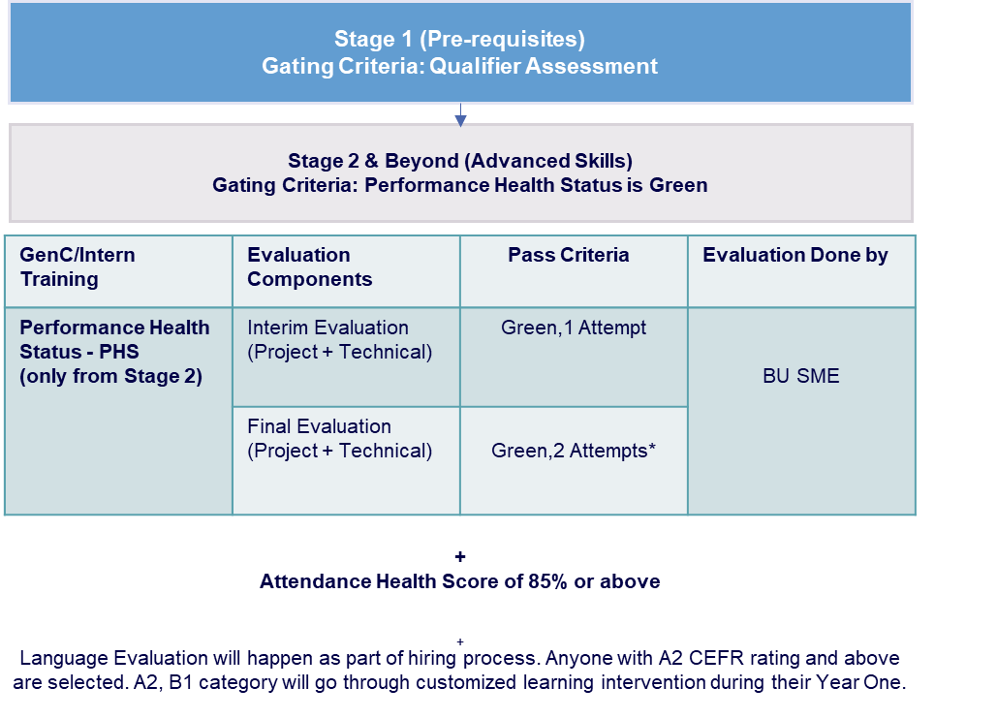

# Code of Ethics - Guiding Principles

All GenC FTEs are expected to adhere to and uphold the Cognizant Code of Ethics (“Code”) to help you ensure that everything you do at Cognizant is in accordance with our standards of integrity. Our Code applies to all Cognizant directors, officers, and employees worldwide as well as all Cognizant business units, subsidiaries, and joint ventures over which Cognizant has operational control (collectively associates”).

The guidelines are to support the GenC FTEs stay focused and on-track w.r.t successful completion of the training program.

Visit the [Ethics & Compliance](https://be.cognizant.com/sites/ethics-compliance/SitePage/289365/ethics-compliance-homepage) page for any questions regarding our Code of Ethics or global policies and procedures.

Please refer below to know about the key policies and guidelines that will govern the GenC FTE skilling in alignment with the organization policies:

|  |  |  |
| --- | --- | --- |
| **Guideline** | **Description** | **Link** |
| **Code of ethics** | The behavior and professionalism of each Associate are critical to creating a safe and harmonious work environment where everyone can thrive and be stewards of Cognizant’s reputation, impact, and success. | https://be.cognizant.com/documents/preview/406771/Core-Values-Code-of-Ethics |
| **Integrity in assessments** | Any learning and assessment are expected to be given by the GenCs in a very honest way. Plagiarism / copying / **any malpractice has a zero tolerance** | *Refer section 10.2* |
| **Dress code** | Our Dress code policy expects our employees to use their best judgment in deciding how they dress at work. | [Dress code policy](https://be.cognizant.com/documents/sppreview/c466eba1-76c9-45e1-aa33-bf49884aedef) |
| **Communication protocols** | All Cognizant associates are expected to comply with the organization’s Communications & social media Policy | [Cognizant 'Communications & Social Media' Policy](https://be.cognizant.com/documents/preview/552934/External-Communications-and-Social-Media-Policy)  Also refer Section 10.4 |
| **Acceptable use policy** | https://be.cognizant.com/documents/preview/520827/Acceptable-Use-Policy |  |
| **Social media security guidance** | https://be.cognizant.com/documents/preview/693393/Social-Media-Security-Guidance |  |
| **Social media security quick tips** | <https://be.cognizant.com/documents/preview/693392/Social-Media-Security-Quick-Tips> | |
| **Prevention of Sexual Harassment Policy - India** | <https://be.cognizant.com/documents/sppreview/95e90182-a4ef-4317-b2fa-089212fafe87>  Refer to section 6.5 for PSH committee details | |
| **Job Abandonment Policy** | <https://be.cognizant.com/documents/preview/832938/India-Job-Abandonment-Policy> | |
| **Global Associate Privacy Notice** | [https://be.cognizant.com/documents/preview/406780/Global-Associate-Privacy-Notice](https://be.cognizant.com/documents/preview/406780/Global-Associate-Privacy-Notice%20) | |
| **Whistleblower & Non-Retaliation Policy** | [https://be.cognizant.com/documents/preview/552931/Whistleblower-and-Non-Retaliation-Policy](https://be.cognizant.com/documents/preview/552931/Whistleblower-and-Non-Retaliation-Policy%20) | |

# Attendance Health score Guidelines

* All GenC FTE trainees are expected to be available for the training at a physical location for all the 5 days in a week.
* Attendance at the physical location & virtual training as applicable must be at least 85% every month to successfully complete the FTE Skilling program
* The Trutime hours logged should comply to Cognizant Working Hours guidelines
* 100% attendance is mandatory in all Instructor led sessions (ILT)
* The total number of hours for mandatory video-based sessions (both technical & behavioural sessions) will be considered for AHS calculation.
  + FTE trainees must be on video to have attendance for all VILT (Virtual Instructor Led Training) sessions.
    - Any breach of this evidenced in email with a concern raised by instructor/Coach/HR GenC will call for attendance not marked for the session and invite a warning resulting in consequence.

### AHS RAG

* The GenC FTE trainee attendance will be reported as AHS RAG
* GenC FTE trainee attendance reports will be generated every fortnight and the cumulative weekly AHS RAG status for **each month** must be in “Green”
* The AHS RAG status will be calculated and reported based on:
  + 1. Trutime hours
    2. Attendance in mandatory ILT/VILT sessions *(manual report of both technical & behavioural sessions)*

85% attendance in both the above parameters is mandated. AHS calculation matrix will be as below:

|  |  |  |
| --- | --- | --- |
| **Actual Trutime** | **Actual session hours reported** | **RAG** |
| >=85% | >=85% | Green |
| >=80% & <85% | >=85% | Amber |
| >=85% | >=80 & <85% | Amber |
| <85% | <85% | Red |

### AHS Consequence

|  |  |
| --- | --- |
| **Monthly AHS RAG** | **Consequence** |
| **GenC** |
| **Green** | Continue with the skilling program |
| **Amber** | De-enrolment from the skilling program. revoked LOI |
| **Red** |

### FTE leave policy

* Attendance to be followed as per the AHS guidelines
* It is mandatory to be in-person or on video for VILT sessions (concern raised by facilitator will be a breach)
* Uninformed leaves of more than 3 days will lead to consequence
* 3 to 4 months in office is mandatory. If the trainees do not have 85% attendance in a month (both physical & virtual), it would lead to unsuccessful completion of the skilling program.
* Leave approvals to be taken in advance through their GenC HR coach – Validated medical leaves from Cognizant medical team only will be permitted
* Notify the GenC HR coach immediately for any Sick/Emergency leave – medical reports to be validated through Cognizant medical team
* All other leaves in any other reasons/categories would have an impact in the AHS attendance. Any uninformed leave(s) would lead to consequence as per AHS guidelines.
* GenC FTE trainees are expected to have uninterrupted access to office mail and are always reachable on mobile phone numbers and MS Teams
* Attendance proxy both giving on behalf of others or availing the act would warrant serious consequence.
* Uninformed Leave >3 days will be moved to No-Show case and Job abandonment will be initiated for GenC FTE.

### Break Scenario

In cases where a GenC FTE candidate is unable to attend training for more than five consecutive working days due to genuine medical or personal emergencies, they may be considered for movement to a Break Cohort, subject to approval from the Program Manager. Once approved, the Batch Owner will update the CRecruit and coordinate with the Supply Management Team to initiate the process. The GenC should be informed in advance, and a tentative rejoining date must be obtained. Upon return, the GenC will be mapped to a cohort based on current demand, which may differ from their original training track. Flexibility in accepting the available technology track is expected.

During the break period, the GenC is advised to apply for Leave/LOP, which may also be initiated by the Batch Owner in HCM. If the GenC does not report back on the agreed date and remains unresponsive for three working days, a Job Abandonment (JA) will be raised on the fourth day.

Rejoining scenarios are handled as follows:

* If the GenC returns before the agreed date, they must obtain approval from the Batch Owner to cancel the LOP and raise a GSD request.
* If the GenC returns on the agreed date, the Batch Owner will confirm cohort availability with the Supply Management Team and facilitate reassignment accordingly.

Throughout the process, the Batch Owner must ensure timely communication with all relevant stakeholders, including the Trainer, Program Managers, Platform Team, and Supply Management Team, to ensure a smooth transition and continuity in training.

# Integrity in Assessments

Any learning and assessment are expected to be given by the GenCs in a very honest way. Plagiarism / copying / any malpractice has a zero tolerance.

The type of disciplinary action(s) would be based on multiple factors attached to the incident and incidents with high severity may call for stringent disciplinary action as per organization policies.

### What constitutes Malpractice

|  |  |  |  |
| --- | --- | --- | --- |
| **S. No** | **Scenarios** | **S. No** | **Scenarios** |
| 1 | Trying to capture and leak questions and/or answers, in ANY mode – mobile pictures, screenshots, streaming etc., | 11 | False declaration of authenticity in relation to the submission of coursework to become eligible for a test. |
| 2 | Copying code or answers or helping to copy from ANY source | 12 | Wasting an attempt to just look at or capture questions |
| 3 | Informing any other parties about the details of the questions and answers, either before or after the assessment through any medium, including verbal or electronic. | 13 | Spurious complaints about system or infra related issues to explain failed attempt |
| 4 | Having someone else take the test for you or help you with the answers in any way or mode. | 14 | Any attempt to compromise the integrity of the exam through any electronic or non-electronic method |
| 5 | Running a parallel test session to gauge questions. | 15 | Trying to look in the other person’s desktop in the assessment hall |
| 6 | Attempt to take assessments in groups | 16 | Discussion in the assessment hall before starting the test/ while attempting or even after finishing your test |
| 7 | Using any electronic devices to capture exam related data or look for answers through any channels. | 17 | Trying to pass answers via rough sheet or any by any other source. |
| 8 | Fabrication of results or evidence | 18 | Using Bluetooth devices during the assessment |
| 9 | Stepping out of assessment hall more than once for drinking water or any other personal reasons. | 19 | Using nonverbal communication **facial expressions, gestures, paralinguistics (such as loudness or tone of voice), body language, eye gaze** |
| 10 | Carrying any additional paper, cheat sheet to the assessment hall |  |  |

# Deployment guidelines

As a full-time employee, trainees will be required to show:

1. Flexibility to work out of any of our Cognizant Location(s), as per the training/ project requirements.

2. Ready to work in any shift, as per the training/project requirement.

3. Ready to work in the technology as per the final graduated skilling track.

# Communication protocols

### GenC Program communication Escalation Matrix

**“Whom shall I reach out to in case of any query”**

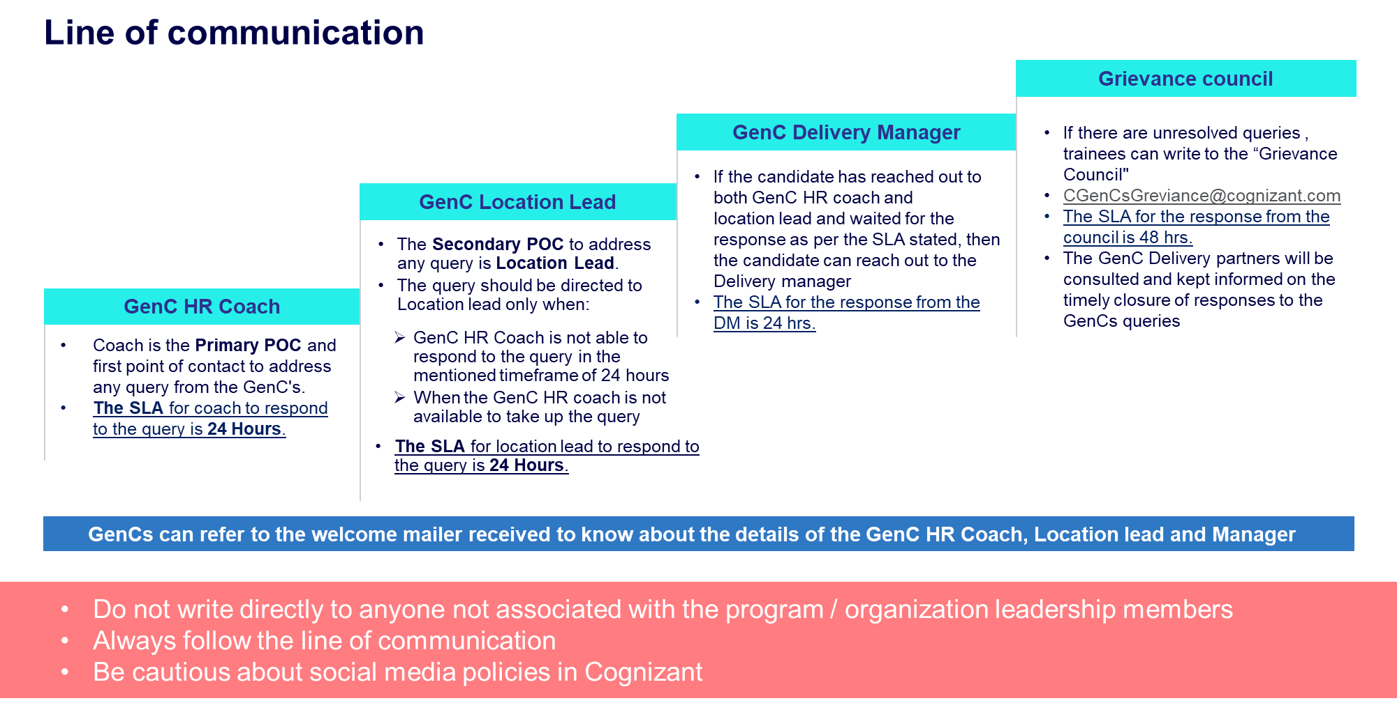

### Mail format

It is highly recommended that the GenC FTE trainees follow the below format while writing regarding their queries for faster resolution

**Mail Template**

|  |  |
| --- | --- |
| **Subject: <<Cohort Code>>_<<Employee ID>> - brief of the issue/query** | |
| **Employee ID** |  |
| **Name** |  |
| **DOJ** | DD-MM-YY |
| **SL** |  |
| **Cohort Code** |  |
| **Coach Name** |  |
| **Delivery Lead Name** |  |
| **Have you reached out to your coach and SL POC earlier?** | Yes/No/NA If no, reach out to your respective PoC. Please send this query to DL only if it is not addressed by both your Coach/Delivery Lead. |
| **Query not addressed by Leads/Coaches** | Explain in 2-3 lines. Attach email proof of the query which was not addressed by Coach/Lead within 48Hours |

# GenC Grievance cell

The objective of the grievance cell is to provide a good learning experience & working relationship for the GenC FTE trainees throughout their journey with the GenC skilling program.

The cell encourages the GenC FTE trainees to express their grievances / problems freely and frankly, without any fear of being victimized

The Grievance cell will focus on advising the trainees to show utmost restraint and patience whenever any occasion of issue/challenges to follow escalation matrix not write to cognizant leadership or write in public domain. Also, advise all GenC program POCs to be more approachable to the GenC FTE trainees and not be unresponsive to their concerns.

### How does the grievance cell work?

Raising a grievance is a 3 steps process wherein the GenC FTE trainees can log their grievance to the cell which will be tracked, monitored, and closed by the Grievance committee

1. 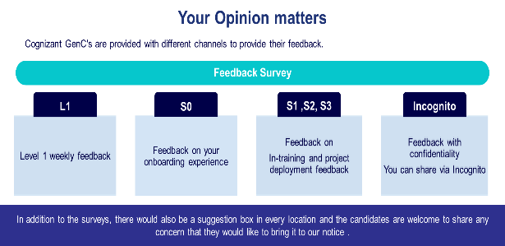Through Incognito survey which will be launched in a specified frequency/timeline during the skilling journey
2. Common mailbox for Grievance [GrievanceCoreTeam@cognizant.com](mailto:GrievanceCoreTeam@cognizant.com) where the concerns can be emailed.
3. Suggestion drop box placed in all the physical location wherein the GenCs FTE trainees can drop a grievance note.

**Link to Incognito survey:** [**https://forms.office.com/r/SPwfQKcedY**](https://forms.office.com/r/SPwfQKcedY)

### Grievance Categories

|  |  |
| --- | --- |
| SME Evaluation failures in 1st, 2nd and both the attempts | **Warning given by the coaches on the guideline breach**   * Dress code guideline violation * Misconduct covering Behavioral, Values and Ethics etc. * Malpractice aligned to lack of learning agility * Communication breach * Training at physical location and AHS attendance |
| Stipend not received on time/Stipend amount is incorrect |
| Issues with company assets |
| Issues with company learning platform |
| Issues with Internal & external SMEs conduct |
| Issues related to BGV, onboarding process and offer letter |

# Feedback communication to the GenC

Performance status will be communicated to GenC FTE trainees at the appropriate checkpoints and will be available on the GenC learning platform dashboard.

The consequence-based feedback will be provided to the GenC FTE trainees based on the performance status at Checkpoint.

* **On Track for successful completion (Green)**
* **Improvement Recommended (Amber)**
* **Critical focus required on progress (Red)**

# Outliers/Exceptions

Any GenC NOT falling under ‘Successfully completed’ or ‘Alternate Service Line’ will not be applicable for the report card from Cognizant GenC skilling program.

# Appendix

# Definitions

| **Component** | **Description** | **Examples** |
| --- | --- | --- |
| Learning and Evaluation Components | The broad parameters that will be applicable for all types of enablement, based on which the evaluation and completion criteria would be determined. | Continuous Learning (Technical & Behavioral)  Hands-on exercises  Qualifier assessments  Interim Technical & Project Evaluation  Final Technical & Project Evaluation |
| Type of Curriculum | The learning path can follow any of the predefined structure as designed by Cognizant GenC skilling program.  Alternatively, based on the business demand; to meet the expectations of learning outcome, customizations would be applied the existing defined learning path [a joint venture between the Service Line (SL) and GenC program team]  A completely niche learning path could be designed by Business team [referred as Service Line (SL) Driven]. | **Standard Skill Tracks**  GenC program driven  **Business Defined Skill Tracks**  GenC program + SL driven  SL Driven |
| Minimum Score/ Expected Status | The score/status that the GenC should obtain to clear a particular Evaluation Component. The score/Status indicates a completion or a skill/technical score, as per the applicability, for the Evaluation Component. | All score-based Assessments – Evaluation score of 70% and above  PHS to successfully complete the training will be “Green” |
| Number of Attempts | Any GenC who has not obtained the pre-defined minimum percentage to clear the Evaluation components will be eligible for reattempt, as applicable. The number of reattempts would be as defined for respective evaluation components in the learning path. | 1 or 2, as prescribed for the Evaluation Components |
| Performance Health Status | Status determined based on the performance by GenC in the evaluation components, applicable for the learning path | Green/Amber /Red status  PHS to successfully complete the training will be “Green” |
| AHS  Attendance Health Status | Cumulative attendance Status of the GenC at physical location and virtual training. | Green/Amber /Red status  Time at Office – 10 hours across all India locations [9 hours for Kolkata and NCR]  TruTime Compliance = “Green” (min 9 hours/day)  Attendance in mandatory ILT/VILT sessions |

# Gen Catalyst Professional Development program

Language assessment level descriptions

The Common European Framework (CEFR) - The CEFR is an international standard for describing language ability. It marks an individual's language skills along a six-mark scale ranging from A1 (beginners) to C2 (advanced)

|  |  |  |
| --- | --- | --- |
| PROFICIENT USER | C2 | Can understand with ease virtually everything heard or read. Can summarize information from different spoken and written sources, can express themselves spontaneously, very fluently and precisely, and explain complex situations |
| C1 | Can express themselves fluently and spontaneously without much obvious searching for expressions. Can use language flexibly and effectively for social, academic, and professional explanation. Can produce clear, well-structured, detailed text on the questions asked clearly with no errors |
| INDEPENDENT USER | B2 | Can understand the main ideas of complex text on both concrete and abstract topics, including technical discussions in his/her field of specialization. Can interact with a degree of fluency and spontaneity Can explain the response to the questions asked with very minimal errors |
| B1 | Can understand the main points of clear standard input on familiar matters regularly encountered in work, school, leisure, etc. Can speak on topics that they are familiar with for e.g., can introduce themselves and answer questions where the response is simple and practiced. Can describe experiences and events, dreams, hopes & ambitions and briefly give reasons and explanations for opinions and plans. |
| BASIC User | A2 | Can understand sentences and frequently used expressions related to areas of most immediate relevance (e.g., very basic personal and family information, shopping, local geography, employment). Can communicate in simple and routine tasks requiring a simple and direct exchange of information on familiar and routine matters.  can respond in complete sentences on topics and questions familiar to him\her. Needs prompting or help in completing sentences to complex questions and responses |
| A1 | Can understand and use familiar everyday expressions and very basic phrases aimed at the satisfaction of needs of a concrete type. Can introduce themselves and others and can ask and answer questions about personal details such as where they live, people they know and things they own. Finds it difficult to respond in complete sentences. Often fumbles, pauses and searches for words to complete the response. Makes a lot of grammatical errors while speaking |

**GenC FTE Skilling 2025**

**Performance Declaration Form**

I Anurag Sanjay Jadhav, undergoing skilling in the GenC FTE skilling program via classroom/virtual mode will be obliged to abide by, acknowledge, and agree to the following:

“GenC FTE skilling completion guidelines 2025” applicable to all types of skilling programs

(Skilling/Re-skilling pre & post onboarding)

**Successful completion of the FTE skilling program is mandatory for eligibility to continue as an FTE & be deployed to Projects.**

**Flexibility regarding location, shift, role, and technology is required during training and project deployment.**

The GenC FTE skilling completion guidelines 2025 document outlines the guidelines and criteria for successful completion of the GenC FTE skilling program:

|  |  |
| --- | --- |
| **Performance Standards** | Performance indicators such as Performance Health Status (PHS - GREEN), Behavioral rating (CEFR > = B2), and Attendance Health Status (AHS – 85%) are mandatory for successful completion. If a GenC FTE trainee fails to meet the performance standards of the skilling program within the stipulated timeline, the trainee will be ineligible for project deployment and continued employment with the organization. HR will initiate Trainee Consequence Management procedures. |
| **Hands-On Completion** | 100% completion of hands-on exercises at each stage is mandatory for eligibility to progress to the next stage. |
| **Mandatory Assessments** | Clearing the Stage-1 assessment and final evaluation is mandatory for successful completion of training and eligibility for deployment to Business Units (BU) in skilling or re-skilling programs. |
| **Zero Tolerance for Malpractices** | Any form of malpractice will be dealt with zero tolerance, potentially leading to immediate de-enrollment from the program and revocation of the LOI. |
| **Attendance Requirement** | All GenC FTEs must maintain minimum 85% attendance at the physical location and virtual training as applicable every month to continue and successfully complete the program. |
| **Exceptions** | There could be exceptions to the applicability of evaluation components and deployment clauses based on demand and training outcomes, subject to ISL discretion and GenC program head approval. |
| **Reporting Discrepancies** | Any discrepancies or deviations observed in the defined process or procedure should be reported to the respective Learning point of contact immediately during the learning journey. |
| **Concerns post-unsuccessful completion** | Concerns raised after failing to meet the expected performance health indicators will not be considered as exceptions to the consequence management process. |

Employee Name: Anurag Sanjay Jadhav Employee ID : 2440835

